|  |  |  |
| --- | --- | --- |
| Name:  Class: | ____________________________________  SCORE:  / 49    ________________ | |
|  | **Year 12 Essential Mathematics**  **Test 5 2021**  **Topic – Interest, Loans & Probability**  ***Full working out MUST be shown to get full marks for each question.*** | |
| **Total Time:** | 50 minutes |  |
| **Weighting:** | 5% |
| **Equipment:** | To be provided by the student: Pen, pencil, ruler, scientific calculator, 1 single sided page of A4 notes | |

1. If I invest $5,500 at 6% p.a. simple interest for 5 years, how much interest will I earn?

(2 marks)

1. If I invest $20,000 at 3.75% p.a. simple interest for 40 months, how much interest will I earn and how much will my total investment be worth in total at the end of the term?

(4 marks)

1. A loan of $3500 was repaid over 3 years with loan repayments totalling $3912.50. What was the annual rate of simple interest? (4 marks)
2. Sarah wishes to invest $3500 for 4 years at 3.5% compounding annually. How much interest will she earn after 4 years? (3 marks)
3. If Janet buys a work vehicle for $35,000 and depreciates the cost over 5 years at a rate of 8% p.a. What would the value of the car be at the end of the 5 years? (2 marks)
4. Kim has $18 000 to invest for 2 years. She has the following options:
5. A building society account, paying a return of 4.56% per annum, compounded monthly.
6. A business venture with guaranteed return of 3.65% p.a., compounded daily.

Advise Kim which option to take: (7 marks)

1. Michelle takes out a home loan for $455 000 with an interest rate of 4.55% p.a., reducible monthly. She makes monthly repayments of $1800. Use this information to complete the table below, showing all your working out in the table.

(12 marks)

|  |  |  |  |  |
| --- | --- | --- | --- | --- |
| **Month** | **Starting Balance** | **Interest** | **Repayment** | **End of month balance** |
| 1 |  |  |  |  |
| 2 |  |  |  |  |
| 3 |  |  |  |  |

1. A builder offers three roof colours, and three interior wall colours. The roofs can be Red (R), Mauve (M) or Cyan (C), and the interior walls can be Navy(N), Yellow(Y) or Pink(P).
2. Show all the colour combinations available, using a table. (4 marks)
3. What is the chance someone will get a Mauve roof with yellow walls? (1 mark)
4. What is the probability they will pick Navy wall, if they have already chosen a Red roof? (1 mark)
5. In a set of four numbered cards, two cards are picked at random and the sum of the two cards is listed in the sample space below. (3 marks)

{15, 10, 8, 11, 9, 4}

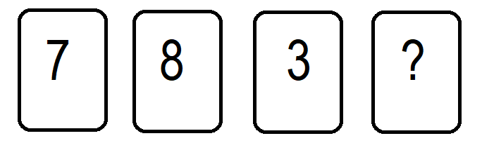

1. What is the value of the fourth card?
2. If two cards are picked at random, what is the probability that the sum of their numbers is even?
3. If two cards are picked at random, what is the probability that the sum of their numbers is at least 10?
4. Dave likes sleeping in and is frequently late for school. The chance that he will be late is 0.4 on any given day.
   * 1. What is the probability Dave will be late to school two days in a row? Draw a tree diagram. (4 marks)
     2. What is the probability Dave will be on time for school the next two days? (2 marks)

END OF TEST 😊